**ProjectDesignPhase-II**

**Data FlowDiagram&UserStories**

|  |  |
| --- | --- |
| Date | 30 October 2022 |
| Team ID | PNT2022TMID34251 |
| ProjectName | Emerging Methods for Early Detection of Forest Fires |
| MaximumMarks | 4 Marks |

**DataFlowDiagrams:**

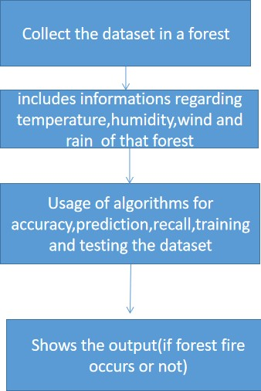

DFD

Level0(IndustryStandard)

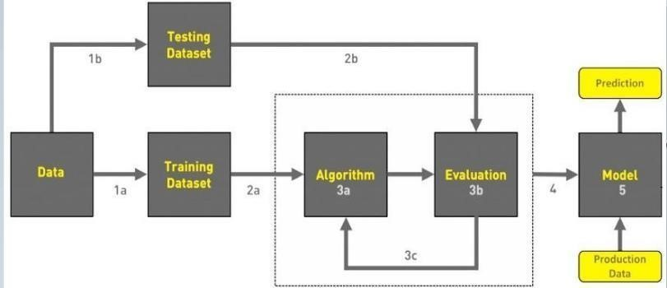

1. COLLECTDATA
2. EVALUATEDATASET
3. IMPLEMENTALGORITHMS
4. EVALUATETHEACCURACYOFEACHALGORITHMS
5. DISPLAYRESULTS

**UserStories**

Use the below template to list all the users to ries for the product.

|  |  |  |  |  |  |  |
| --- | --- | --- | --- | --- | --- | --- |
| **UserType** | **FunctionalR equirement**  **(Epic)** | **User**  **StoryNum**  **ber** | **UserStory/Task** | **Acceptancecriteria** | **Priority** | **Release** |
| Environmentalist | Collect the data | USN-1 | As an Environmentalist,it is necessary to collect the data of the forest which includes  temperature,humidity,wind and rain of the forest | It is necessary to collect the right data else the prediction may become wrong | High | Sprint-1 |
|  |  | USN-2 | Identify algorithms that can be used for prediction | To collect the algorithm to identify the accuracy level of each algorithms | Medium | Sprint-2 |
|  |  | USN-3 | Identify the accuracy of each algorithms | Accuracy of each algorithm calculated so  That it is easy to obtain the most accurate output | High | Sprint-2 |
|  |  | USN-4 | Evaluate the Dataset | Data is evaluated before processing | Medium | Sprint-1 |
|  |  | USN-5 | Identify accuracy,precision,recall of each algorithms | These values  Are important for obtaining the right output | High | Sprint-3 |
|  |  | USN-6 | Outputs from each algorithm are obtained | It is highly used to predict the effect and to  Take precautionary measures. | High | Sprint-4 |